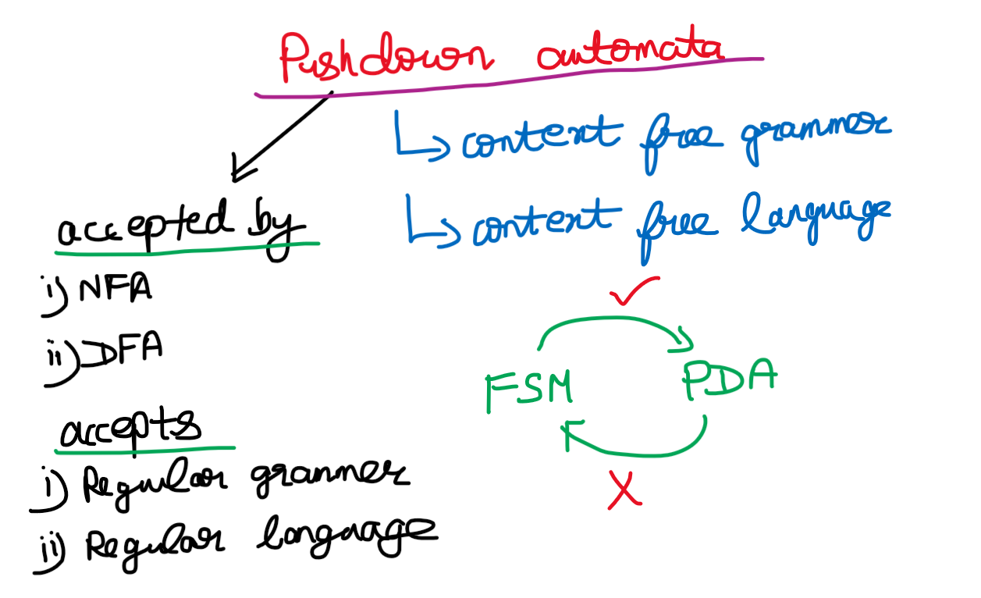  
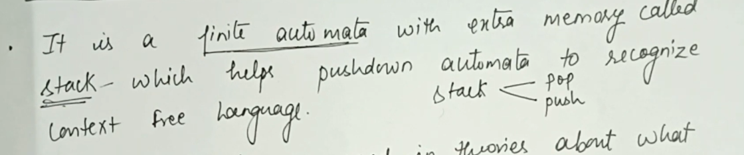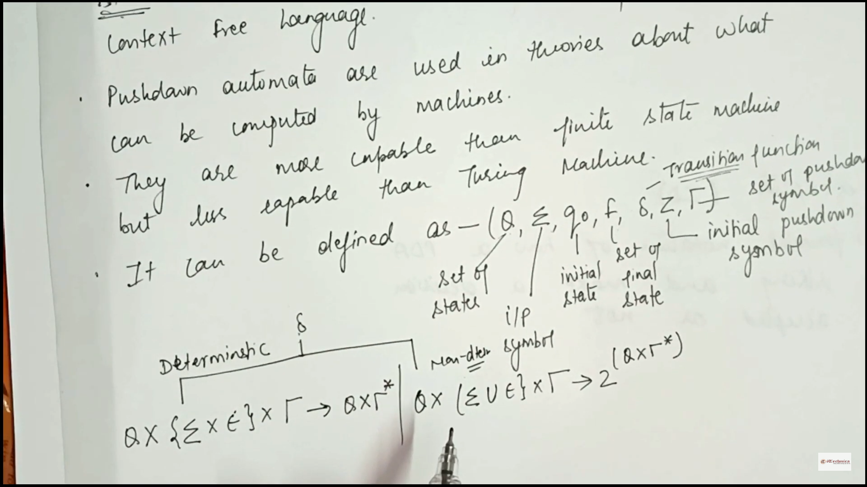

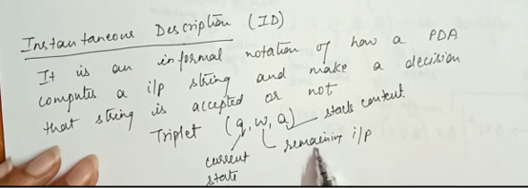

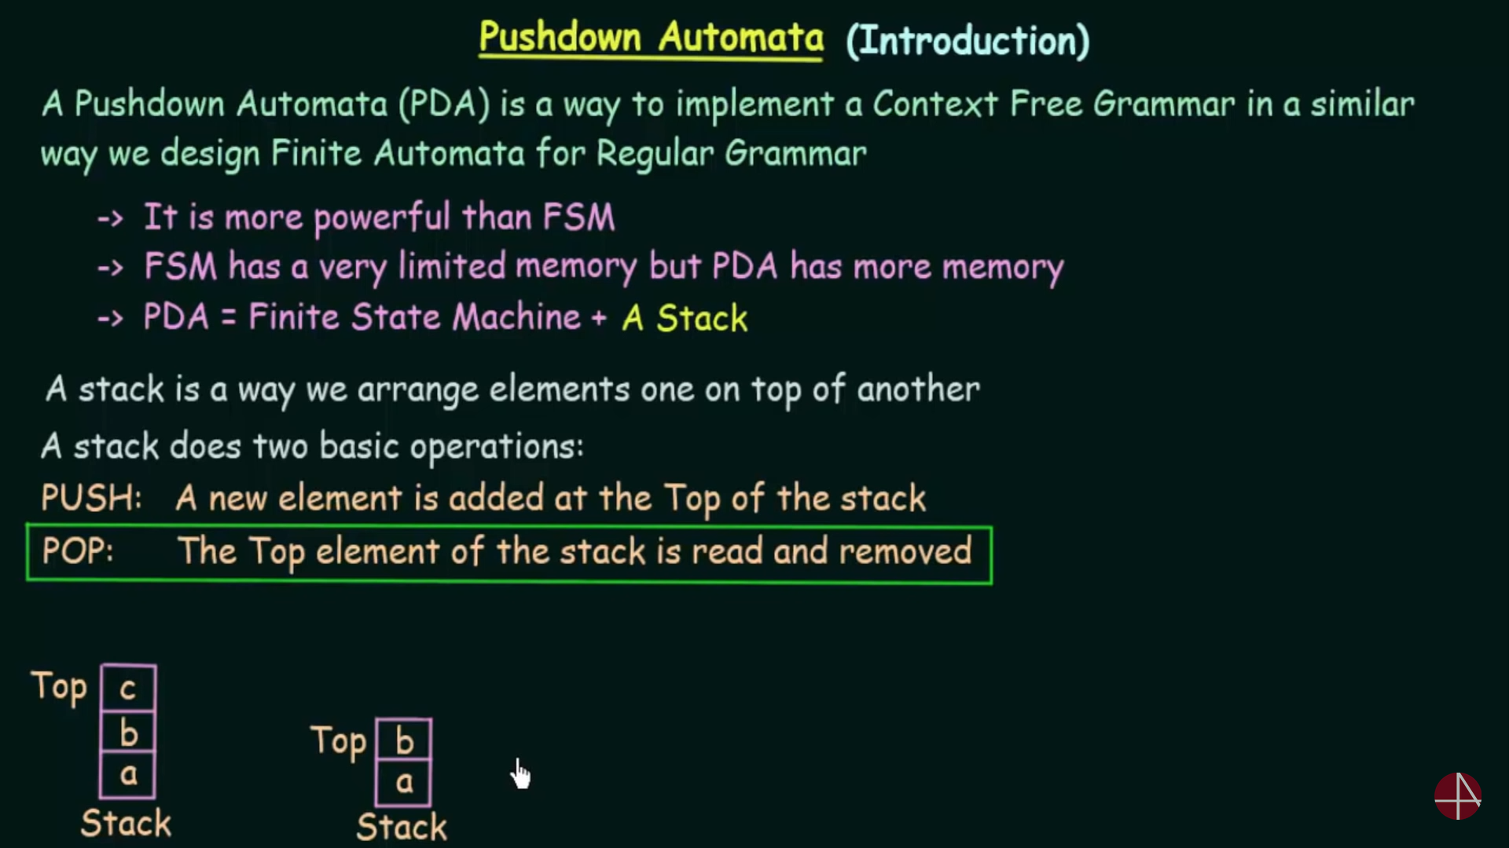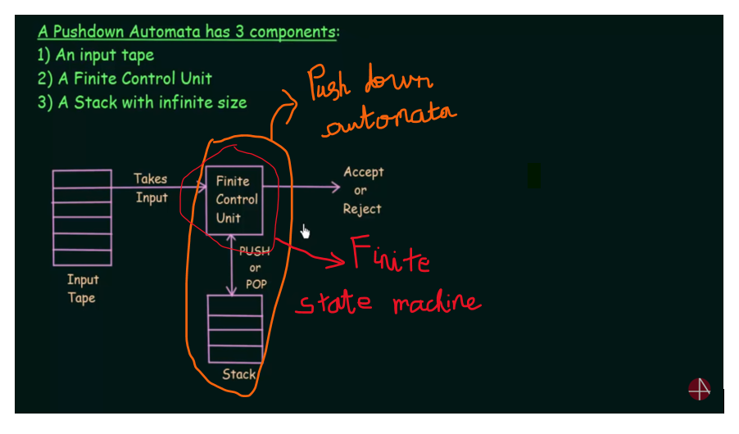

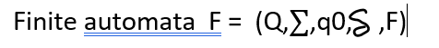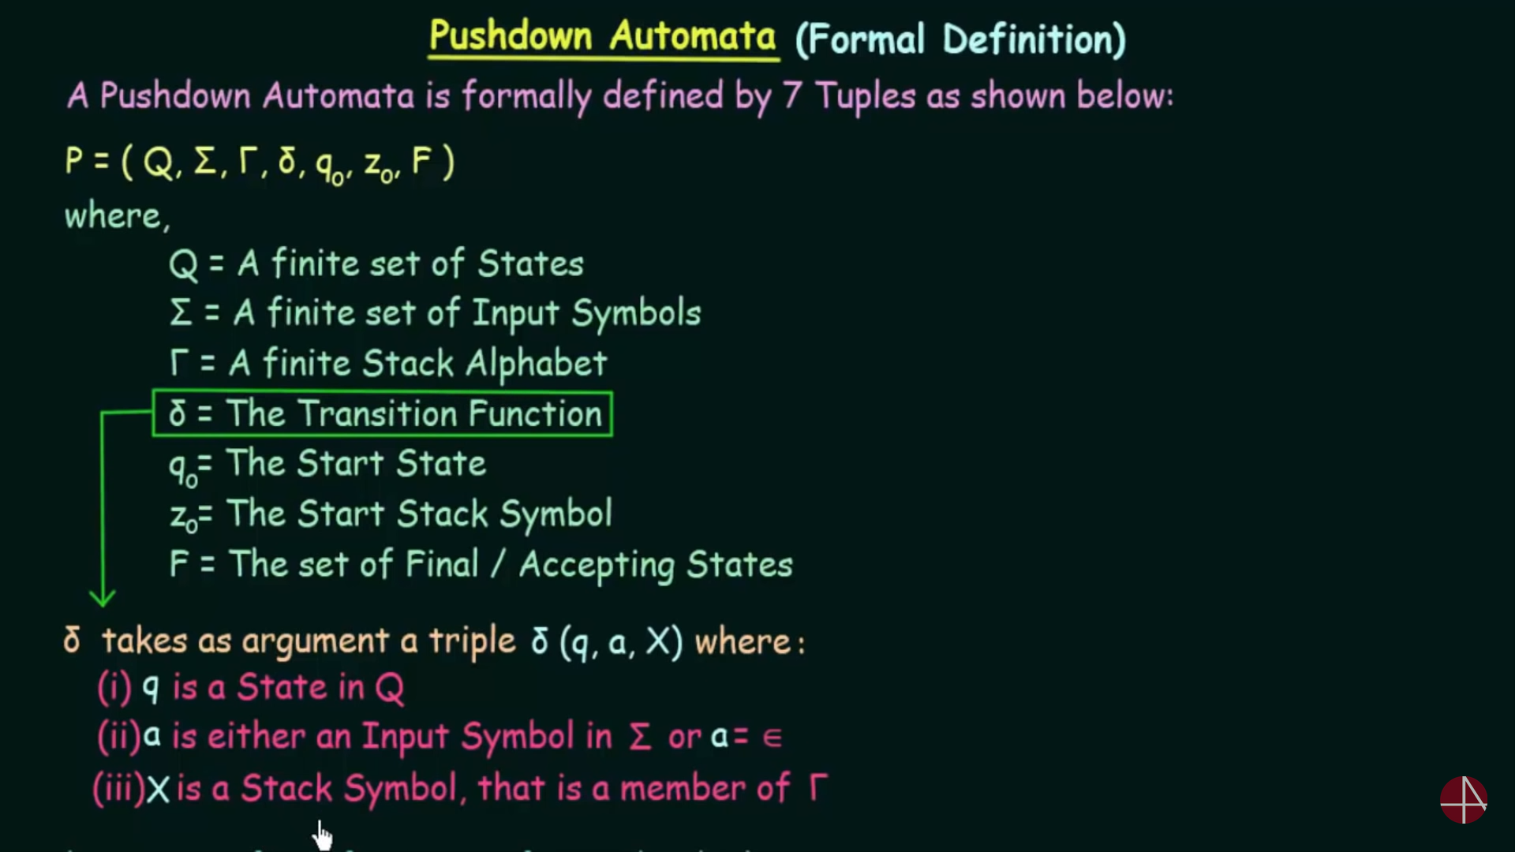



The transition function for finite automata is entirely different from push-down automata.

FA = (Q, $∑$)   
PDA = (Q1, $∑,$ Z0) 🡪 (Q2, V)



Q1 is one state and it is changed to Q2 which is another state.  
 🡪 one input alphabet   
Z0 🡪 top of the stack

(q1,a,b) 🡪 (q2,epsilon)   
[a 🡪 input symbol(cursor) and b 🡪 top of the stack]  
If V 🡪 epsilon (Whenever the stack’s top and the cursor symbol are different they are cancelled eachother.

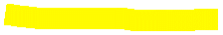

(q1,a,z) 🡪 (q2,az)   
If V 🡪 az (Whenever the stack is empty (i.e denoted by z) and the cursor symbol is about to enter into the stack.



(q1,a,a) 🡪 (q2,aa)  
If V 🡪 aa (Whenever the top of the stack and the cursor symbol are same then that cursor symbol will be added to the stack instead of cancelling.



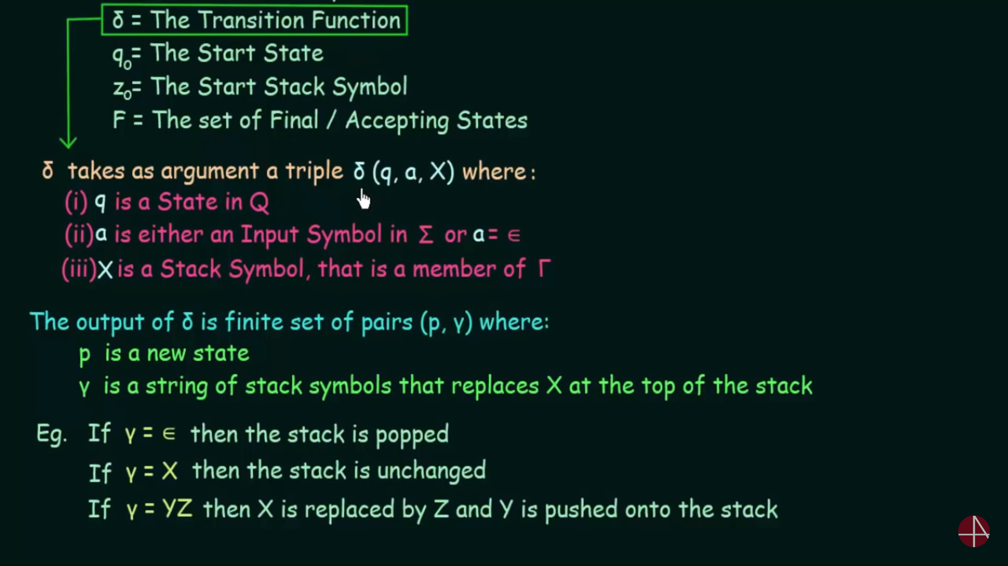

**Instantaneous Description**

**Instantaneous Description** (ID) is an informal notation of how a **PDA** “computes” a input string and make a decision that string is accepted or rejected.

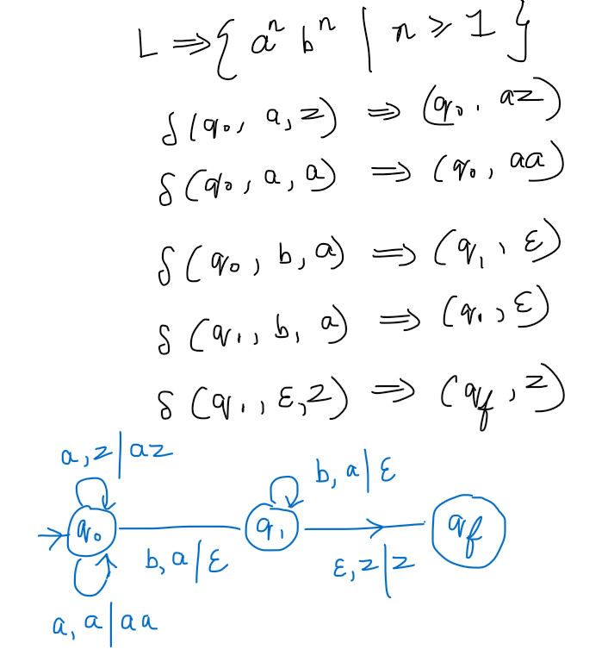



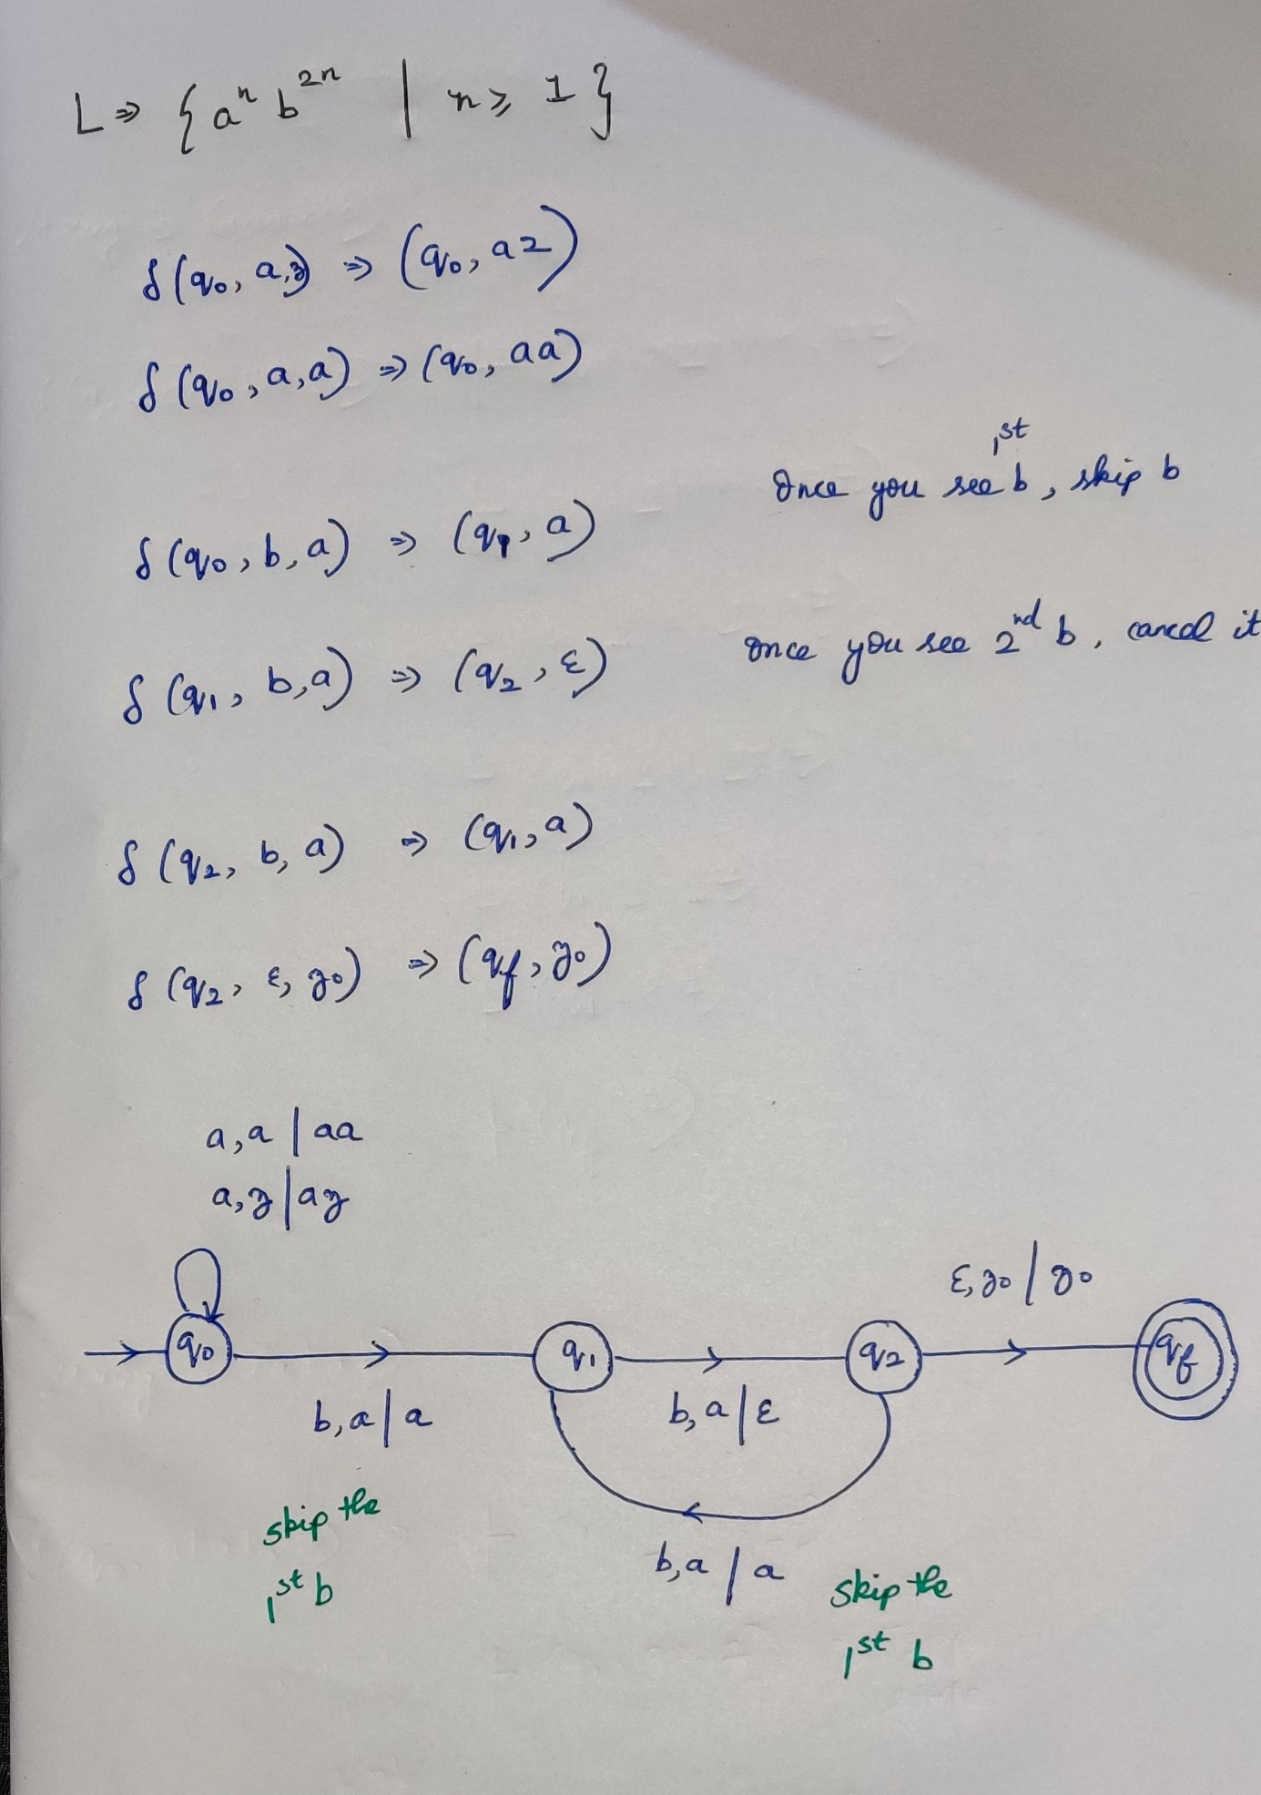



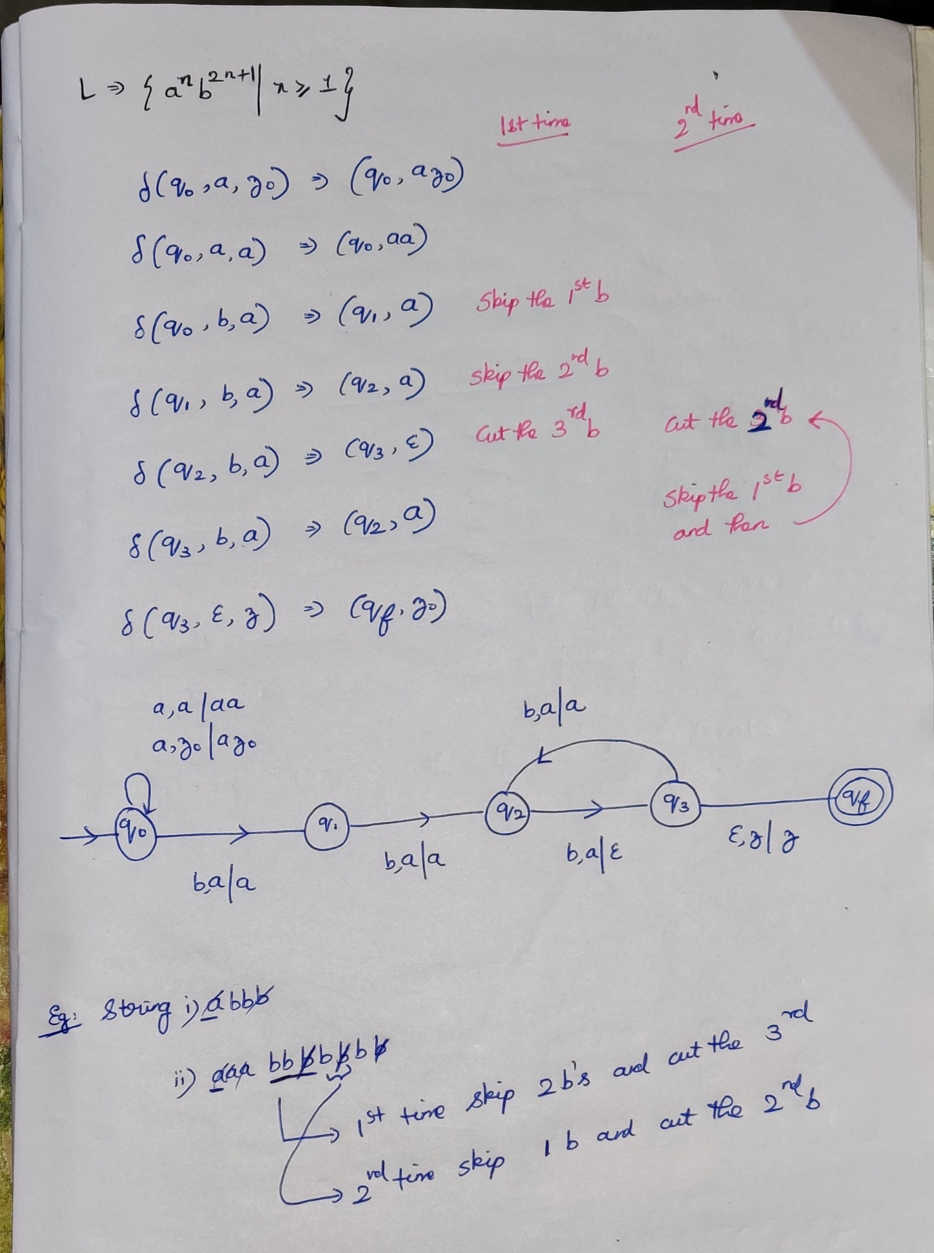



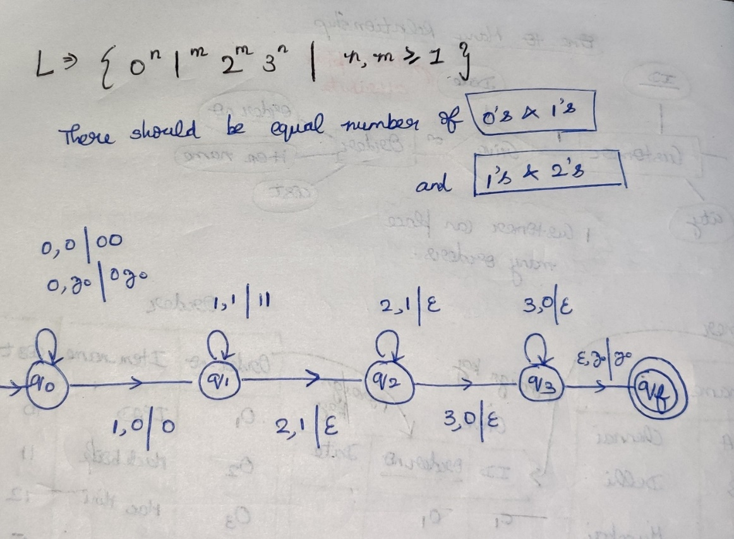



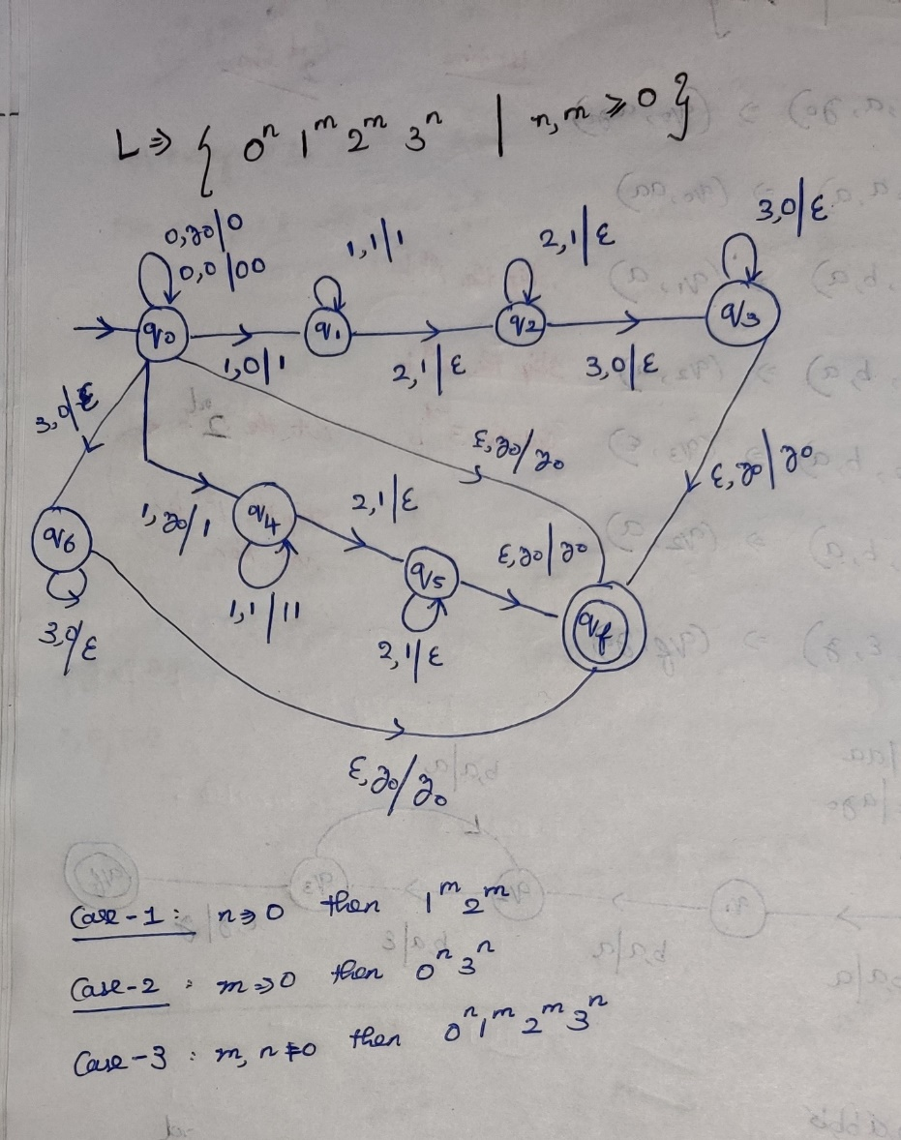



**6) L = {na(w)=nb(w) | w belongs to {a,b}* }**  
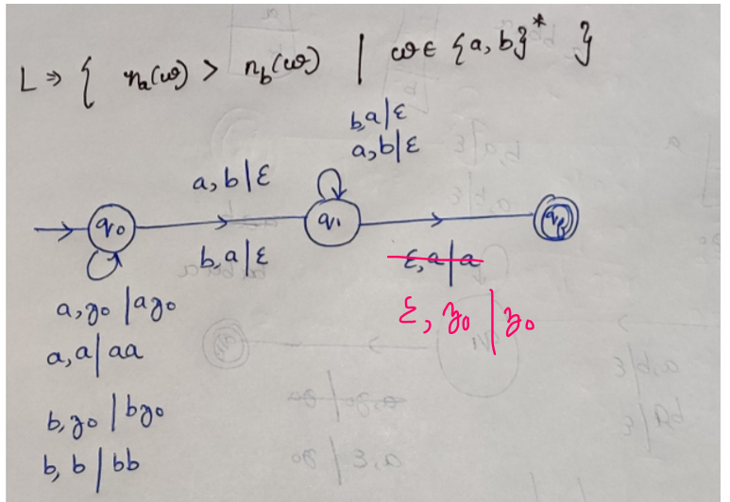



**7) L = {na(w)>nb(w) | w belongs to {a,b}* }**

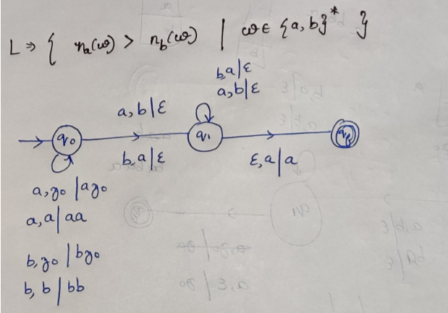

**8) L = { ww^R | w belongs to {a,b}* }**

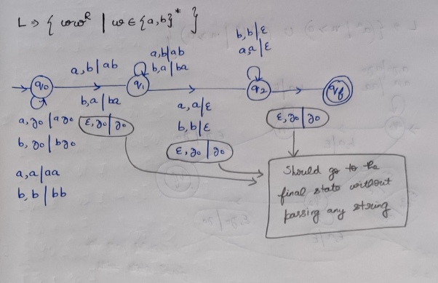

**9) L = { wcw^R | w belongs to {a,b}* }**

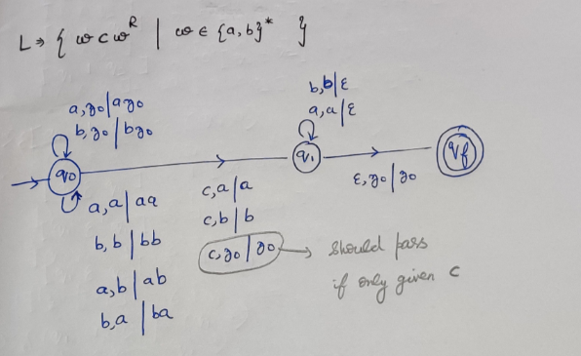



L = { a^n b^n c^m | n,m>=1 }



L = { a^n b^m c^n | n,m>=1 }



L = { a^m b^n c^n | n,m>=1 }



L = { a^n b^n c^m d^m| n,m>=1 }



L = { a^n b^m c^m d^n| n,m>=1 }



L = { a^(m+n) b^m c^n | m,n>=1 }



L = { a^m b^(m+n) c^n | m,n>=1 }



L = { a^n b^n c^m d^m | n,m>=1 }

**Deterministic Push Down Automata**

L = { (a^n b^n | n>=1) **U (**a^n b^2n | n>=1) }  
L = { ww^R | w belongs to {a,b}* }  
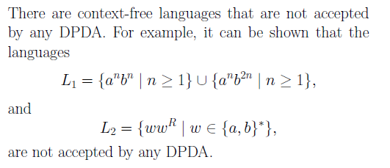

**1)L = {na(w)>nb(w) | w belongs to {a,b}* }**

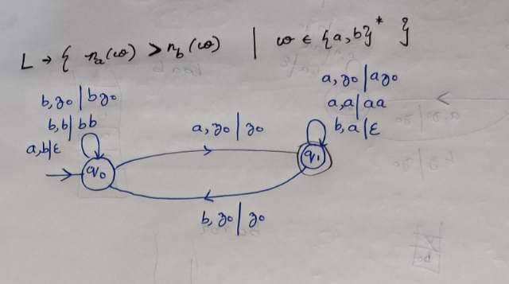

**2)L = {na(w)=nb(w) | w belongs to {a,b}* }**

**2)L = { (a^n | n>=0) U (a^nb^n | n>=0) }**

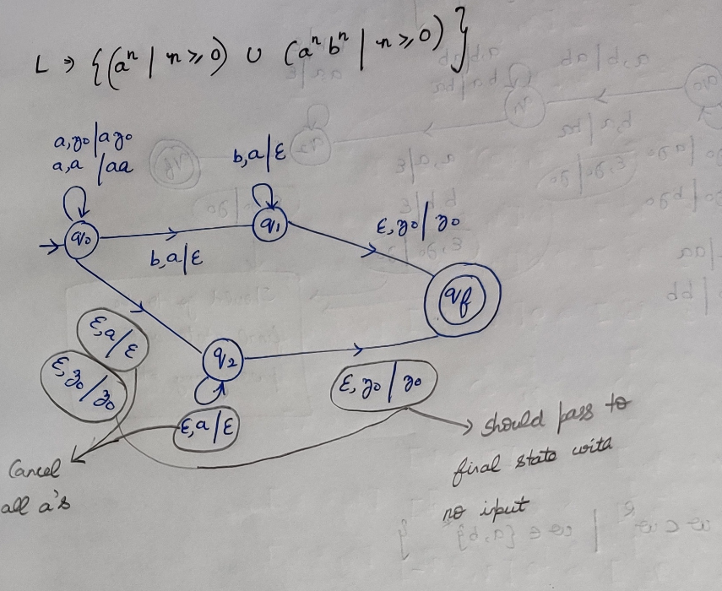

**Equivalance of CFG and PDA**

**Context free grammar to Push Down Automata**

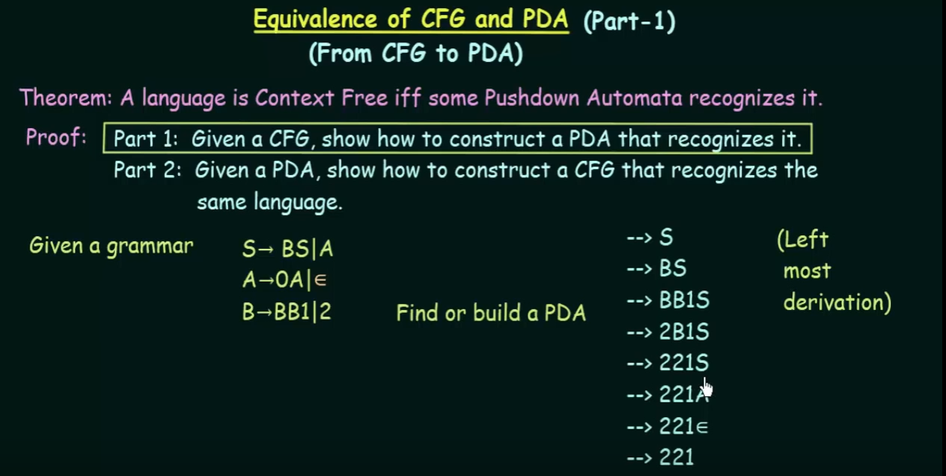

When the top of the stack meets the production rule, then push all the elements into the stack.

Non-Terminal on the top of the stack

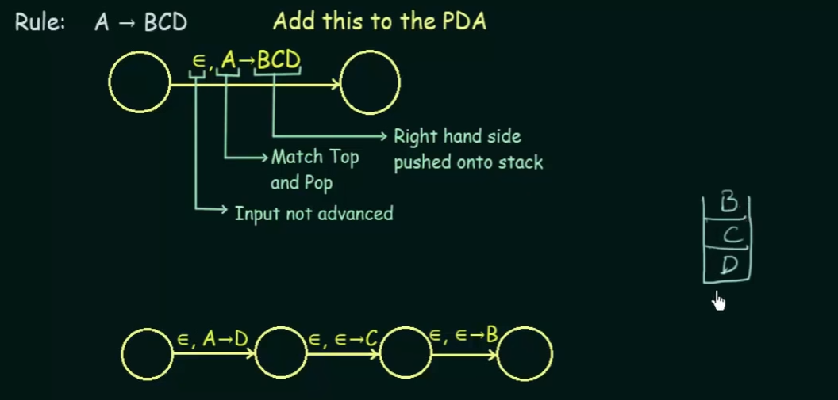Push the elements into the stack in the reverse order.   
(i.e) Rule: A🡪BCD, then push D,C,B. By looking the stack from the top to bottom it will look as BCD. Don’t advance the input.

Terminal on the top of the stack

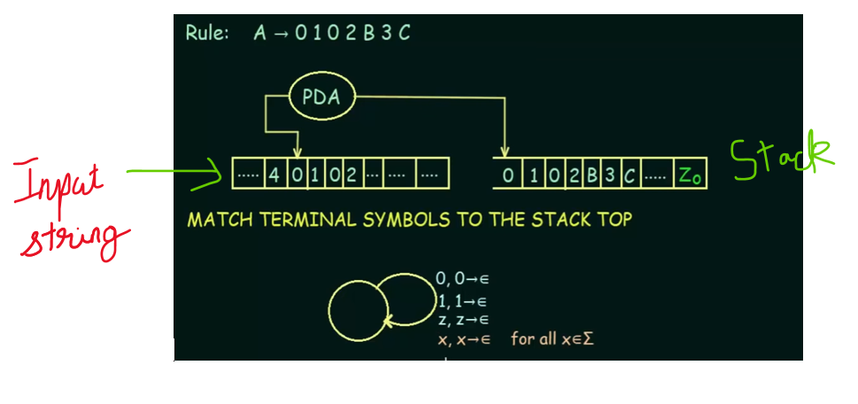

Assume that A was on the top of the stack, and matched with a production rule A🡪0102B3C. After matching we should pop that A and push the right hand-side elements into the stack.

Then we have to look whether top of the stack matches with the input symbol, if matching then cancel it (i.e pop it out) and proceed for the next input element (i.e Advancing the input symbol) and look on the top of the stack.

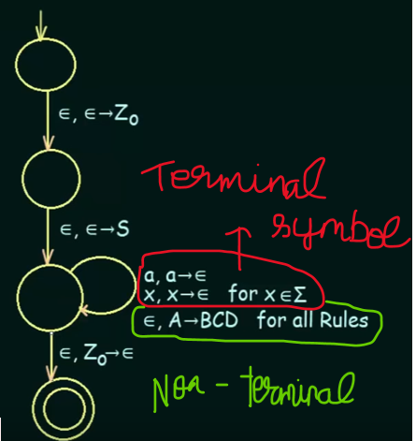



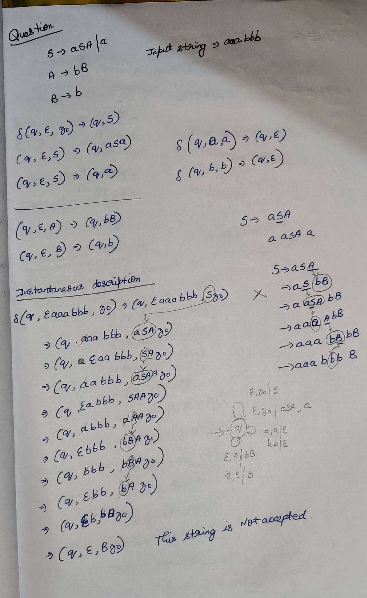

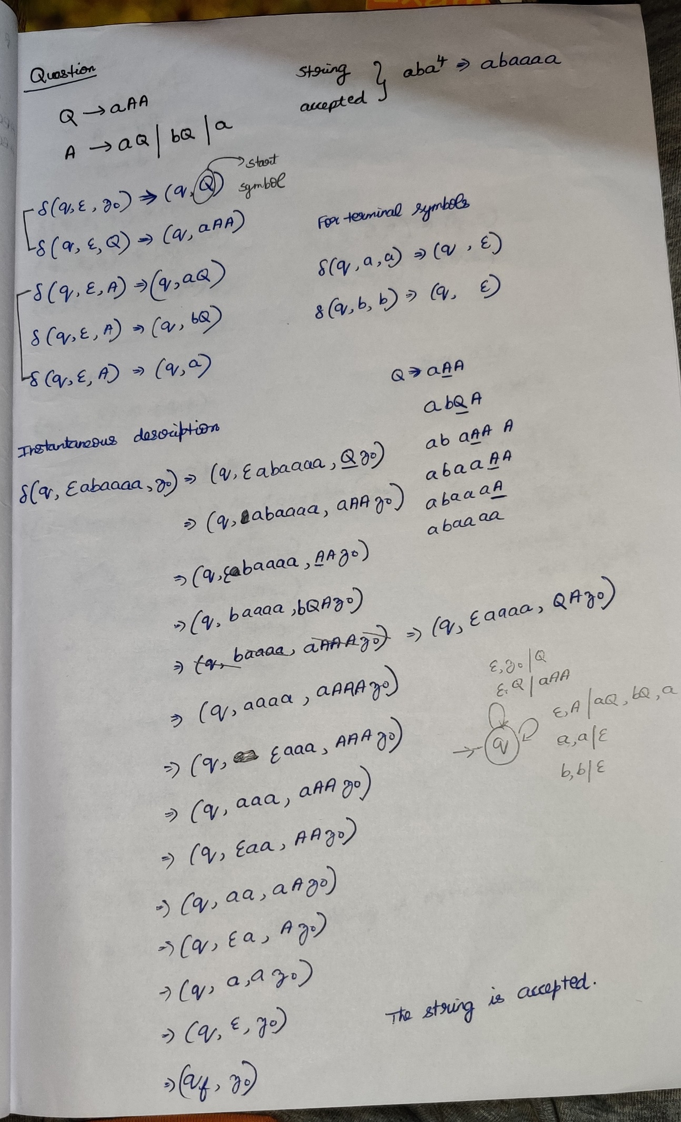

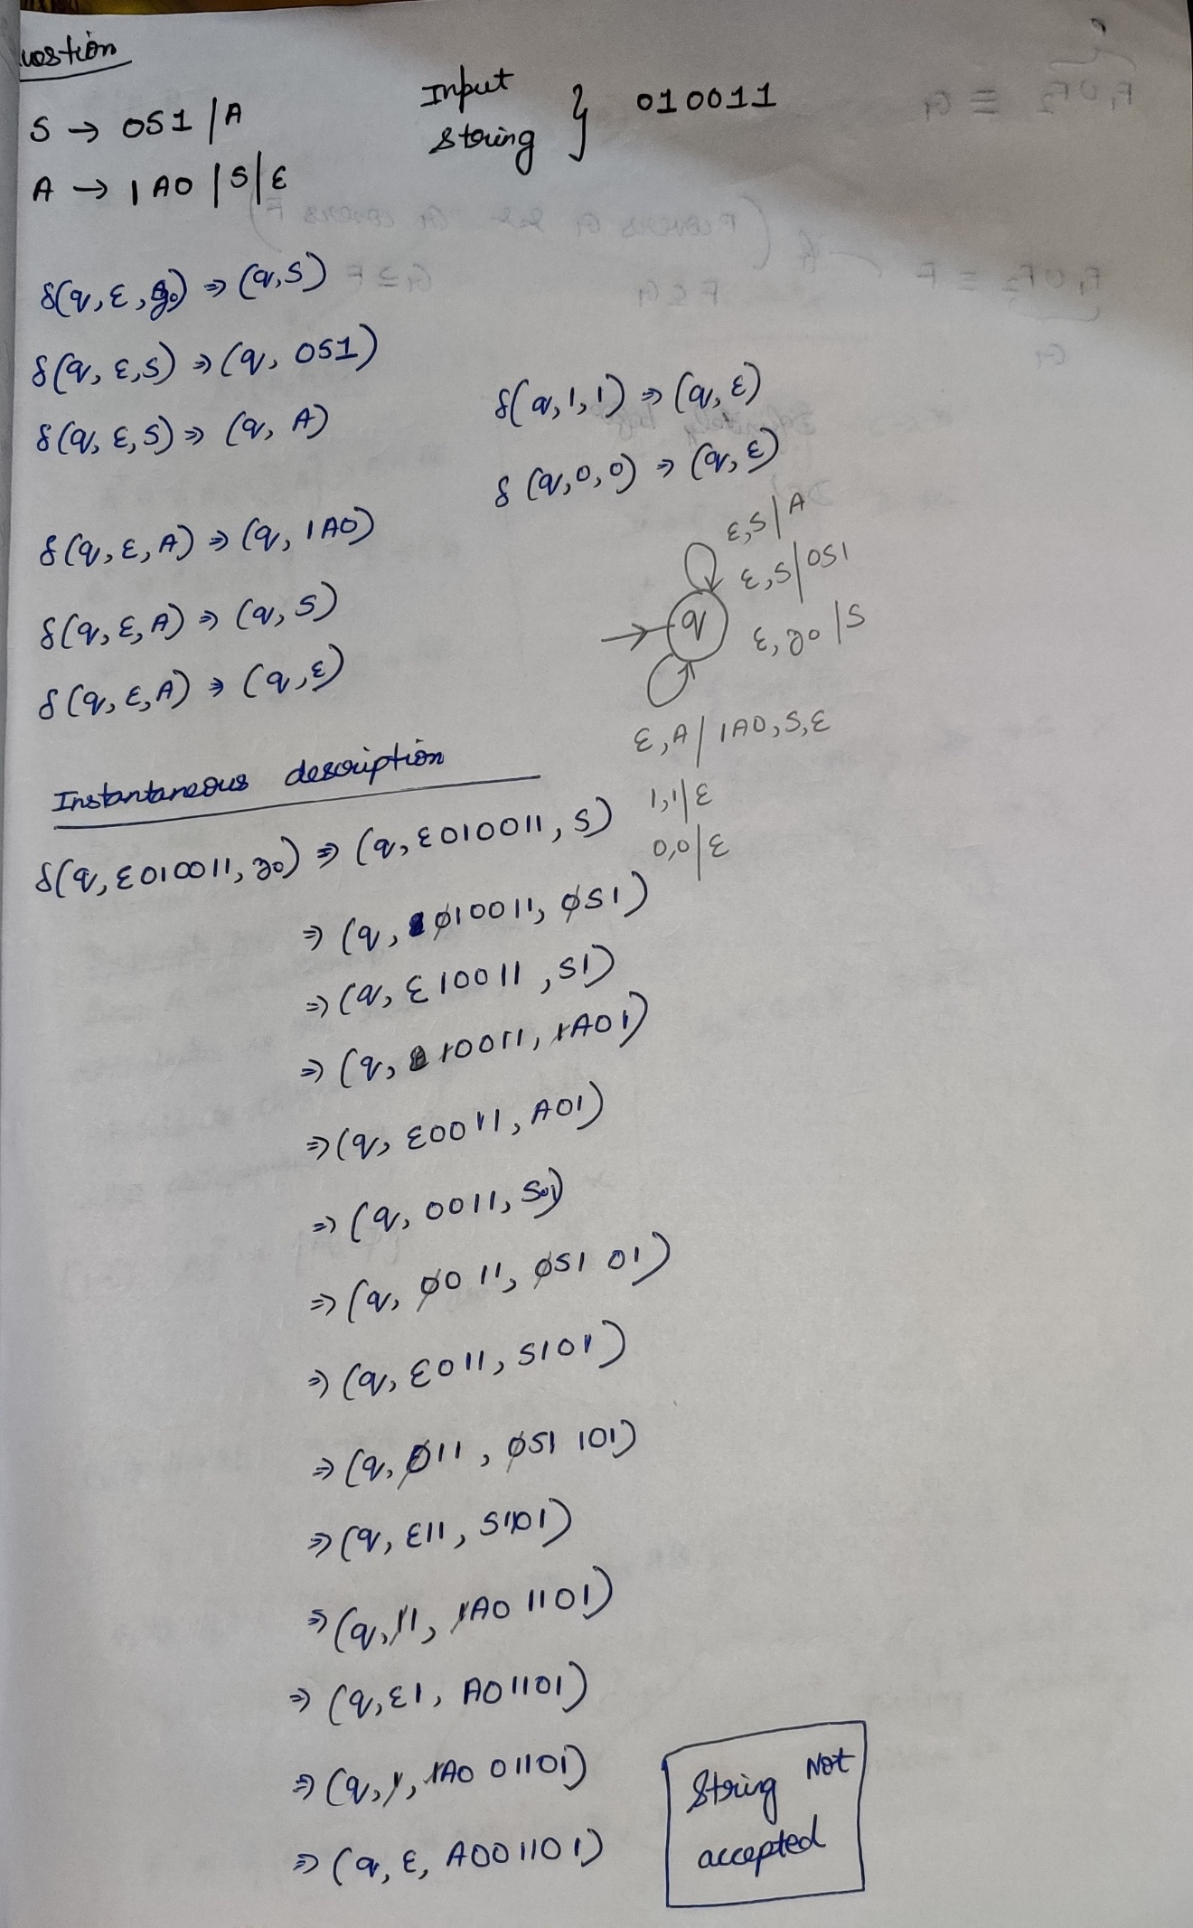

**Push Down Automata to Context free grammar**

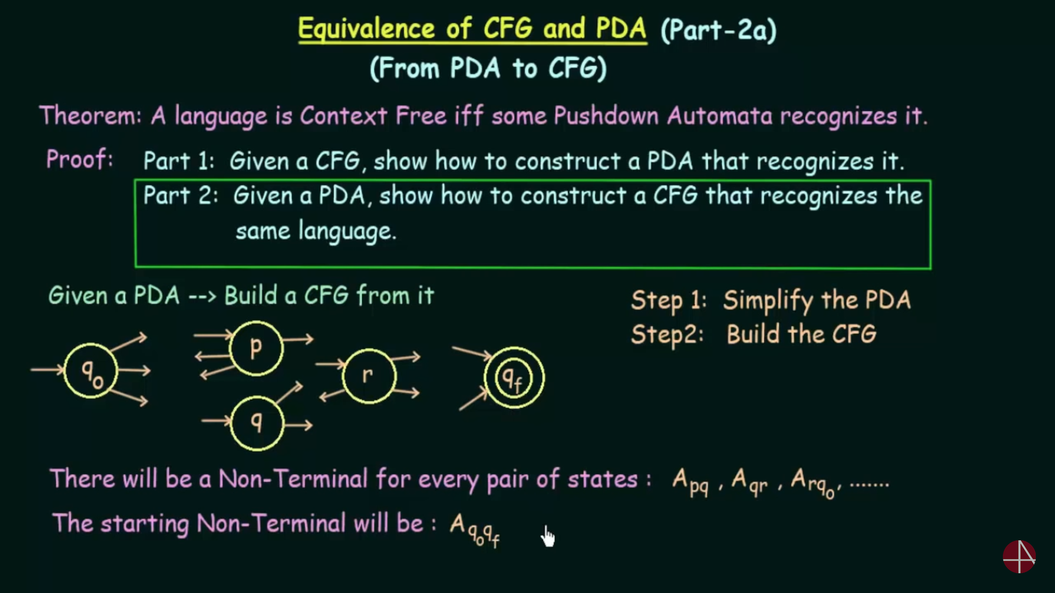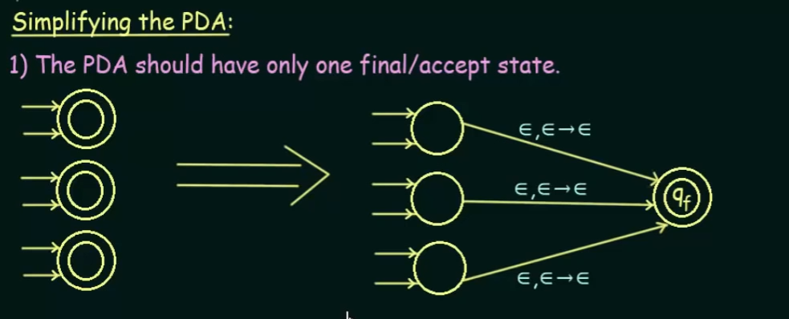

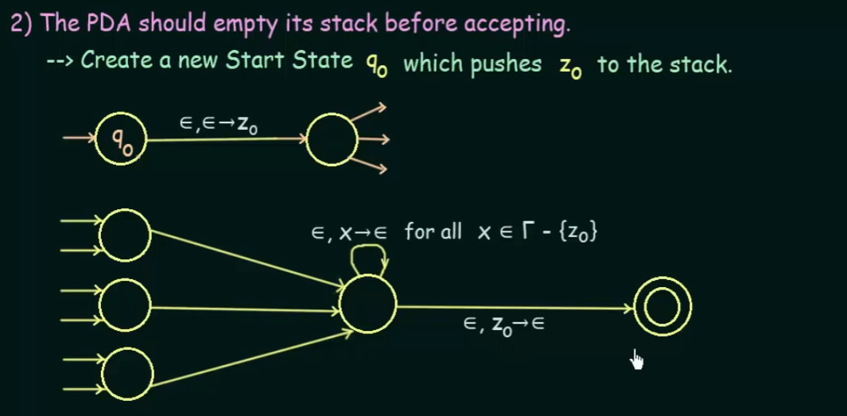

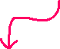

Pop all the elements from the stack except z0.

a,x|y 🡪 then a is read, x is popped out of the stack and y is pushed into the stack. This should be not there. In each transition there must be either push/pop not the both.

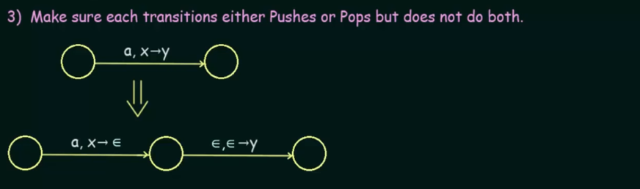



a is read and x is popped out y is pushed

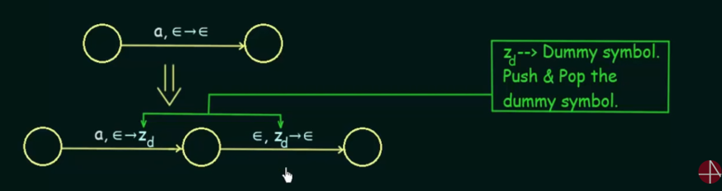

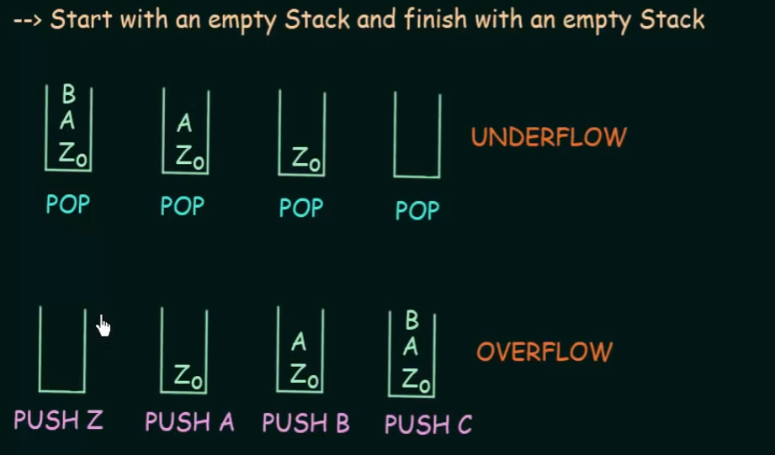

Underflow occurs when we try to pop out the elements from an empty stack.

Overflow occurs when we try to push the elements into the stack beyond its limit. This is not related to pda, since in pda we will not fix any limit to the stack.

